**Data Structures**

It is a way for organizing the data into the memory efficiently. Data structures are classified into 2 types.

1)Primitive Data Structures: it can hold only single value.

Example: int, float, char, pointer etc.

2)Non primitive data structures: it can hold more than 1 value,

Example: array, linked list, tree and graph.

* Again, non-primitive data structures are classified into two types.

1. Linear data structure 2) Non-linear data structure

* Linear Data Structures: Arranging the data in sequential manner where one element is connected to next element.

Examples: array, linked list, stack, queue etc.

* Again, linear data structures is classified into two types

1. Static linear data structures: it is a type of data structure where size is allocated in compile time.

Example: array.

B) Dynamic linear data structures: it is a type of data structure where size is allocated in run time.

Example: stack, list etc.

* Non-linear Data structures: Arranging the data in sequential manner where one element is connected to “n” elements.

Examples: graph, tree etc.

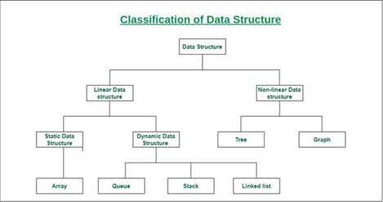

**STACK**

* Stack is a linear data structure where insertion and deletion operations are performed at same place.
* Stack follows basic principle called **LIFO / FILO.**
* Operations: Display, Insertion = push and deletion = pop
* Basic Structure :

Int a[]

**QUEUE**

* Queue is a linear data structure where insertion and deletion operations are performed at two different places.
* Insertion will be takes place at rear and deletion will be take place at front.
* Queue follows basic principle called **FIFO / LILO.**
* Operations: Display, Insertion = Enqueue and deletion = dequeue.
* Basic Structure:

Int a[]

Queues : FIFO(first in first out)

Array -------------------------queues

+front and raer

Struct queue

{

int a[5];

int front;

int rear;

}